**Introduction to Cloud Computing**

**(DV1566)**

# **Laboratory 2**

To practice with the fundamental cloud mechanisms and resources

Group 20:

[AVAN CHOWDARY GOGINENI](https://bth.instructure.com/groups/25181/users/29455)

[LAHARI GADDAM](https://bth.instructure.com/groups/25181/users/29457)

[SREE LAKSHMI HIRANMAYEE KADALI](https://bth.instructure.com/groups/25181/users/31279)

# **TASK 1:**

**Setup and run an amazon EC2 instance**

* **Creating a VPC:**

In the following step, we will be creating a VPC from VPC console in the Amazon VPC wizard. The steps include different tasks like

* Creating a VPC with /16 IPv4 CIDR block.
* Creating and attaching an internet gateway to our VPC.
* Creating two subnets (private & public) using two different Ip addresses.
* Creating custom route tables for public and private subnets and associates with their respective subnet.

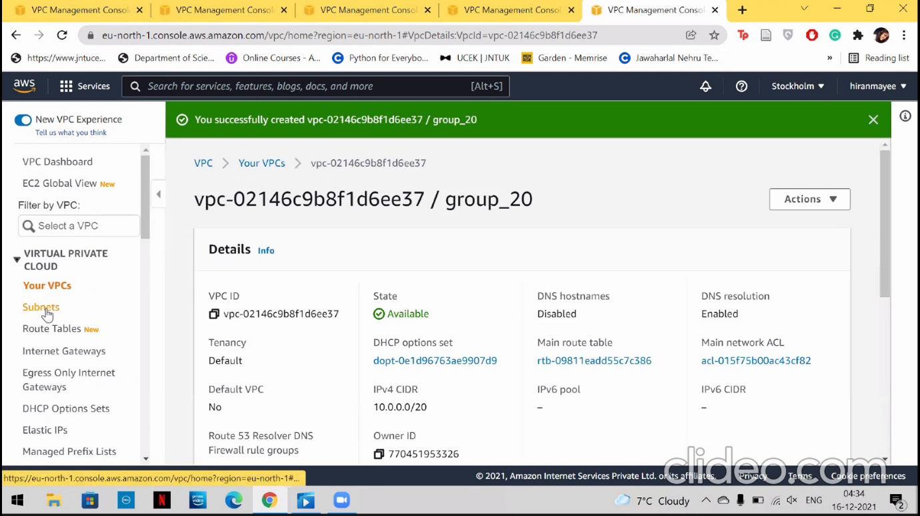

Figure 1 NEW VPC

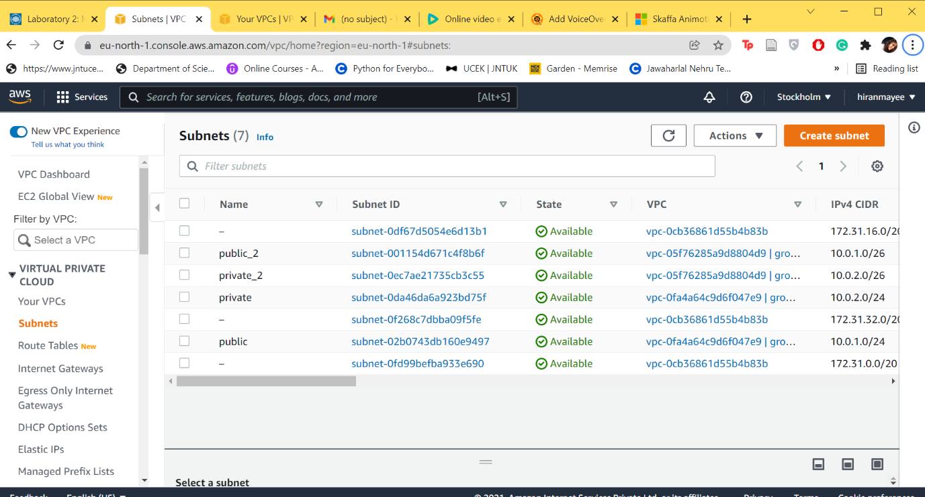

Figure 2 SUBNET

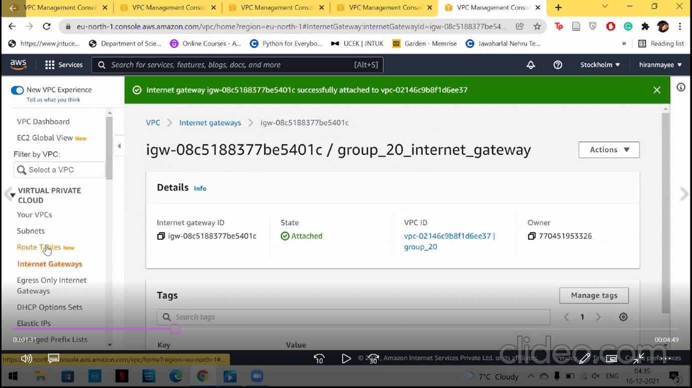

Figure 3 NEW INTERNET GATEWAYS

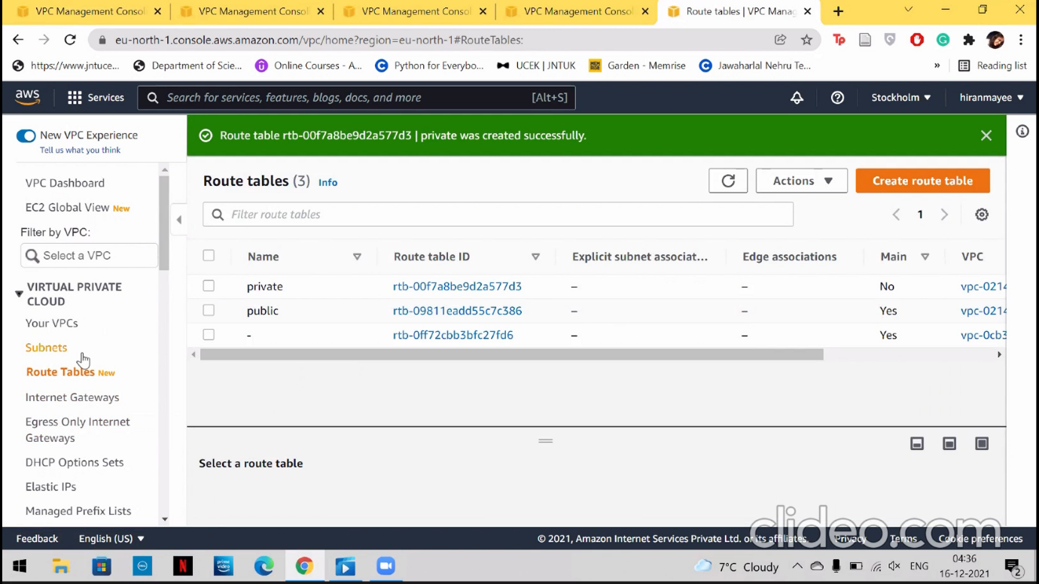

Figure 4 ROUTE TABLES

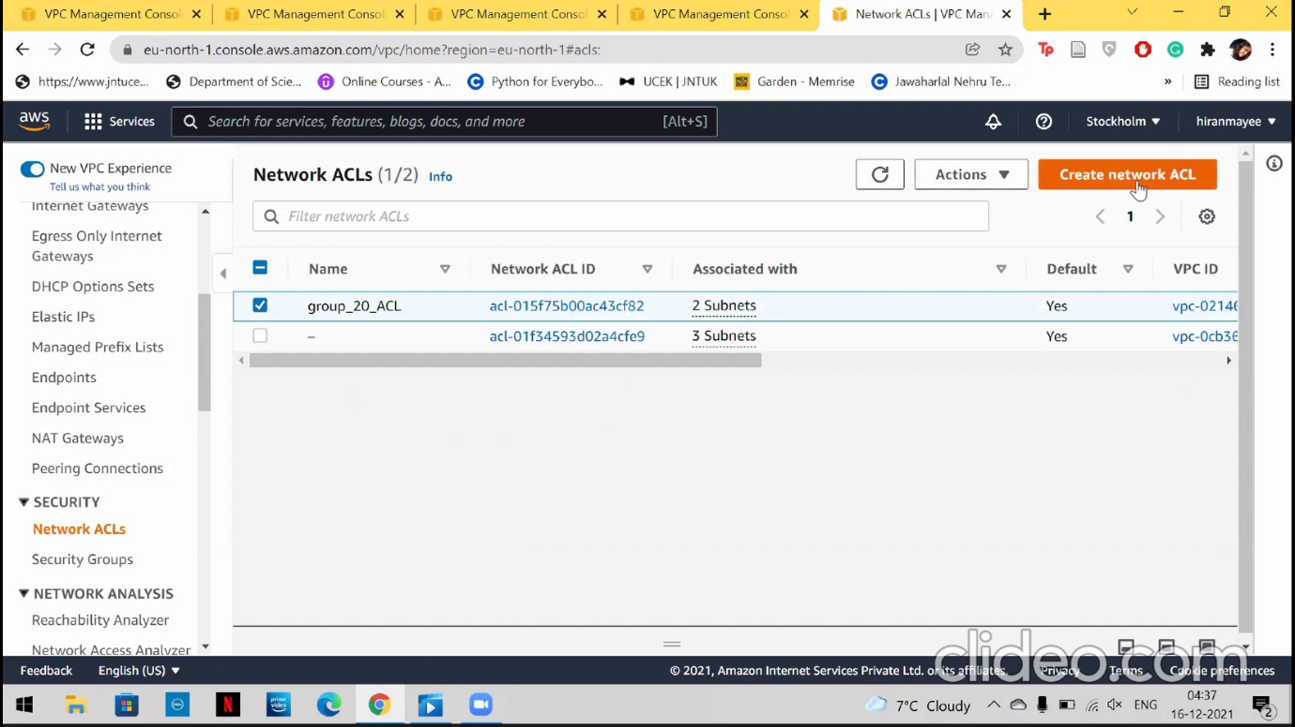

Figure 5 NETWORK ACL

* **Creating a security group:**

In Amazon VPC wizard, a security group can be created when certain credentials such as security group name, VPC, Inbound rule and an Outbound rule are given. This can be done by clicking on the “Security Group” tab and selecting “create” option.

* **Configurations of our Security Group: -**

**Security group name**

Group_20

**Security group ID**

Sg-0e68914ad71773ce7

**Description**

Connection to server

**VPC ID**

Vpc-02146c9b8f1d6ee37

**Inbound rules**

SSH – 0.0.0.0/0

**Outbound rules**

All traffic – 0.0.0.0/0

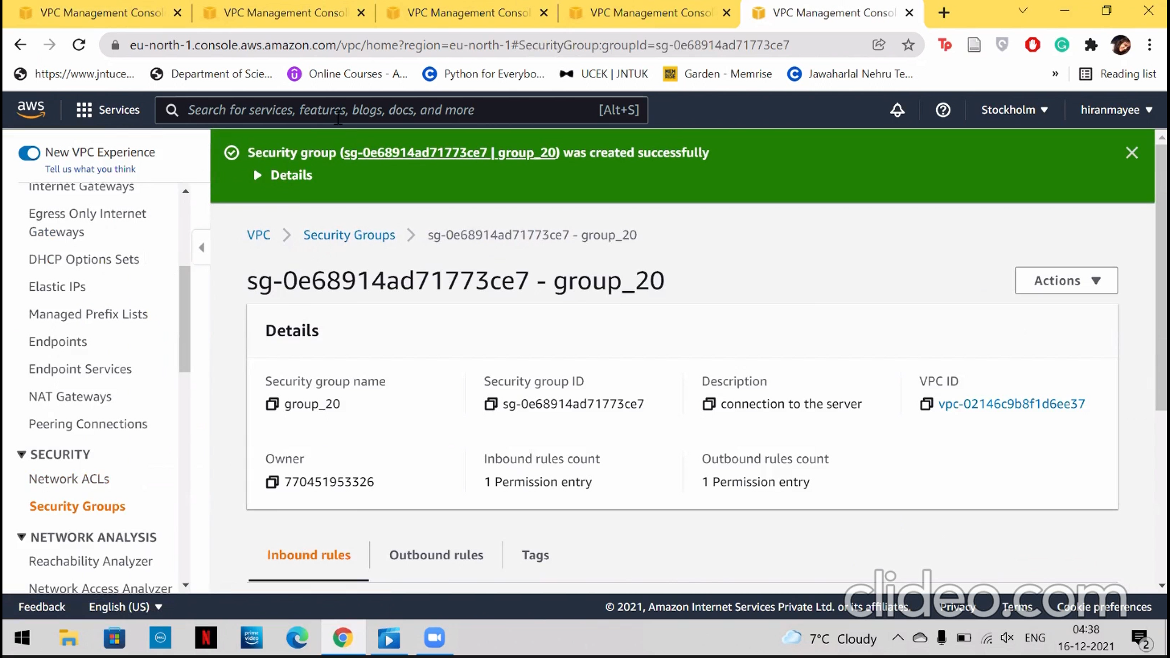

Figure 6 SECURITY GROUPS

* **Creating virtual machine using EC2:**

After successfully creating VPC, we can create a virtual machine using an instance in EC2. To launch an instance, we click on AMI with the respective free eligibility options. We have selected Ubuntu server of 64 bit for our Lab. Next, we choose the instance type, we have selected t3 micro. Following, we configure the instance by changing the network to our VPC, we have created and enable the public subnet setting. Adding a tag to the instance, we give a name called Ubuntu Linux to the instance. Now we are ready to launch the instance, as soon as we downloaded the private key. Connection to EC2 management console will be done when we input the IP address as well as the private key in PuTTY.

Now, we have successfully launched a virtual machine in AWS.

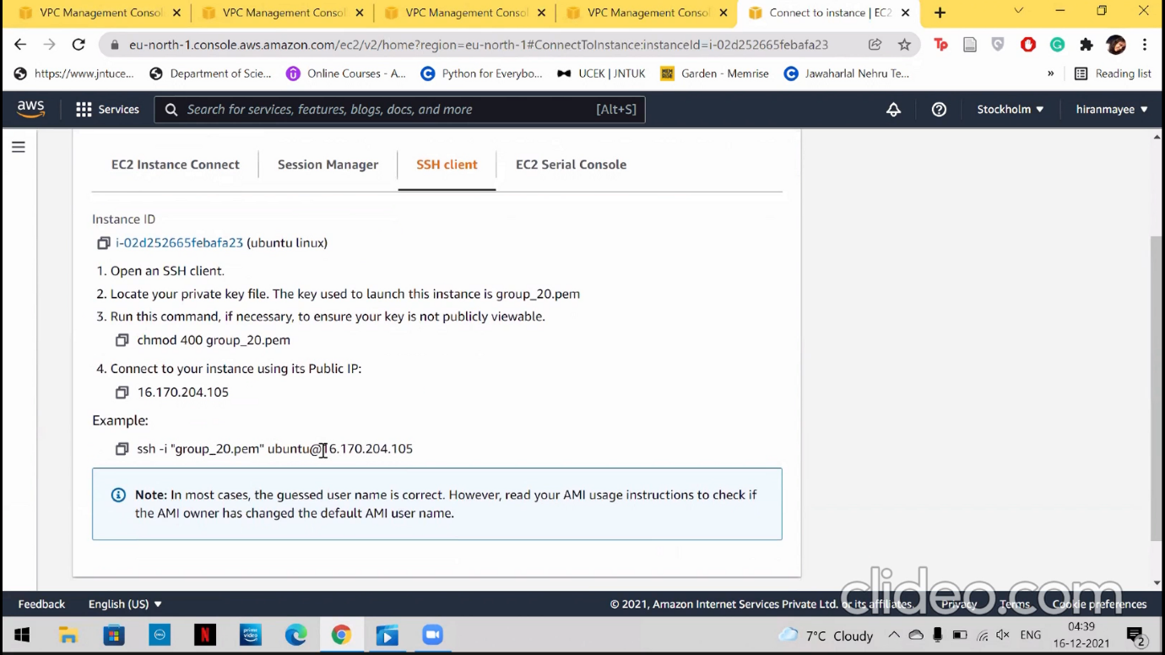

Figure 7 VM IS LAUNCHED SUCCESSFULLY

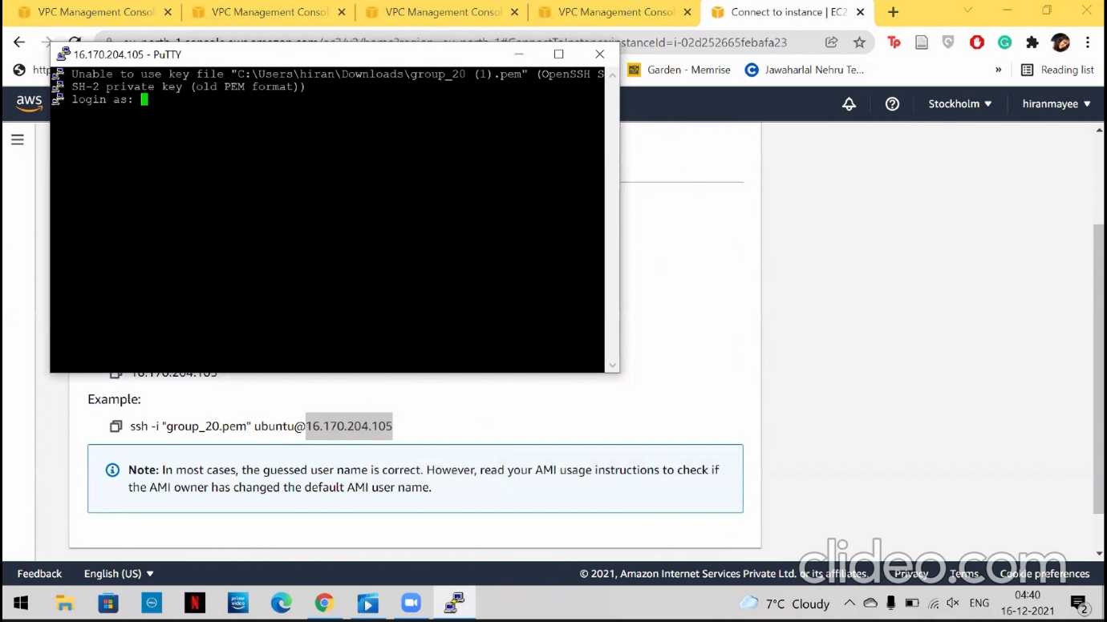

Figure 8 PUTTY IS CONNECTED

**Motivation:**

Initially, learning about the services was a difficult task. Later when we came to know how to create the services such as VPC, security group, routing tables and subnets. Creating and attaching the subnets to the internet gateway also gave us issues. Editing subnet associations was simple. Later, after a few failed attempts, we have successfully launched an instance and accessed it by the SSH.

**TASK-2: MONITORING VMs**

We create a dashboard for monitoring the metrics in the cloud watch. As we have selected t3 micro instance, we get the following metrics for monitoring our amazon instance.

The following metrics are to be monitored by the cloud watch:

* + - * CPU utilisation
      * NetworksPacketsIn
      * NetworksPacketsOut
      * NetworkIn
      * Network Out

We created a dashboard in cloud watch naming “group_20” to watch the metrics. To add metrics in the dashboard we select the metrics by clicking on “add dashboard” option. We have selected metrics with respect to our instance to observe the performance.

Sysbench is used to generate intensive workload for the VM, the following commands are given to generate the load

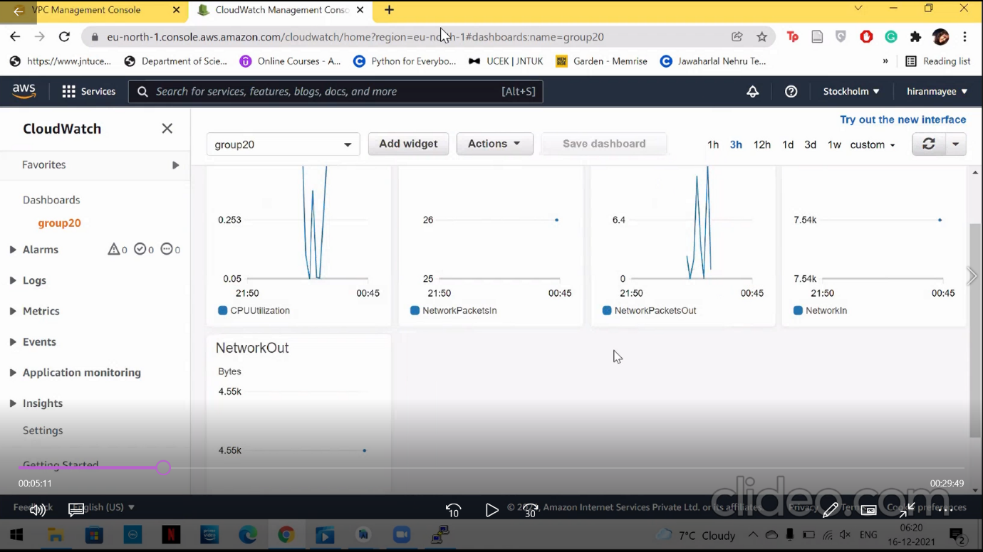

Figure 9 MONITORING METRICS

**for each in 1 4 8 16 32; do sysbench --test=fileio --file-total-  
size=6G --file-test-mode=rndwr --max-time=240 --max-requests=0 --  
file-block-size=4K --file-num=3 --num-threads=$each run; done;**

The application sysbench generates a certain number of files with a specific size given initially. The reason is to make each thread execute I/O operations on the files. We have run the sysbench for six times with an increasing random range.

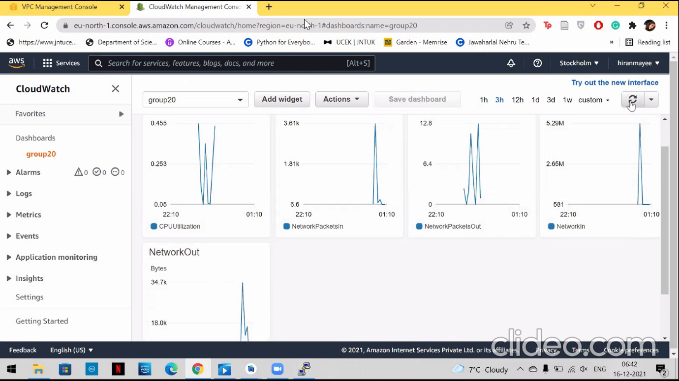

Figure 10 MONITORING METRICS

**for each in 1 2 4 8 16 32 64; do sysbench --test=cpu --cpu-max-  
prime=200000 --num-threads=$each run; done**

It can be made more accurate by performing more CPU intense test by increasing the number of iterations and increasing the range.

**MOTIVATION:**

The reason behind choosing the specified metrics (CPU Utilization, NetworksPacketsIn,

NetworksPacketsOut, NetworkIn and NetworkOut) is that out instance is not EBS backed instance store, where the metrics are zero. Therefore, we gave the metrics a priority for understanding the accuracy and performance of the created instances. Initially, we were confused when each locality server is customized to different metrics. Then, we tried to understand that the instance we created is T3 micro and doesn’t have EBS backed up metrics. So, we have chosen different metrics.

**TASK-3:**

Firstly, we created a web page on the http server and created a pair of VMs in a VPC, in which we already have existing Ubuntu VM. We created a new ubuntu VM for the task. Now, using public IPs, we created a connection between the VMs using PuTTY.

As we have established the connection, we now create a new dashboard “group_20_task3”, and added line metrics (CPU utilization, NetworksPacketsIn, NetworkPacketsOut, NetworkIn, NetworkOut) and stacked area (EBS readops, EBS readbytes, EBS writeops, EBS writebytes).

For this task, we used the following commands.

* **Installation of the web services:**

**sudo apt-get update -y**

**sudo apt-get install -y apache2**

The above is used for installing Apache server on VM1(Ubuntu Linux).

**sudo systemctl start apache2**

The above command is used to start the service.

**sudo systemctl status apache2**

The above command is used to view the activity status of the service

**sudo apt-get update -y**

**sudo apt-get install apache2-utils**

The above is used for installing apache2 server on VM2(Ubuntu linux).

**sudo systemctl start apache2**

The above command is used to start the service.

**sudo systemctl status apache2**

The above command is used to view the activity status of the service.

**1.3.3 Connection between two VMs:**

The following command is used to create a connection between two VMs:

**wget** [**http://13.51.121.176/**](http://13.51.121.176/)

The given IP address is the public IP address of VM1.

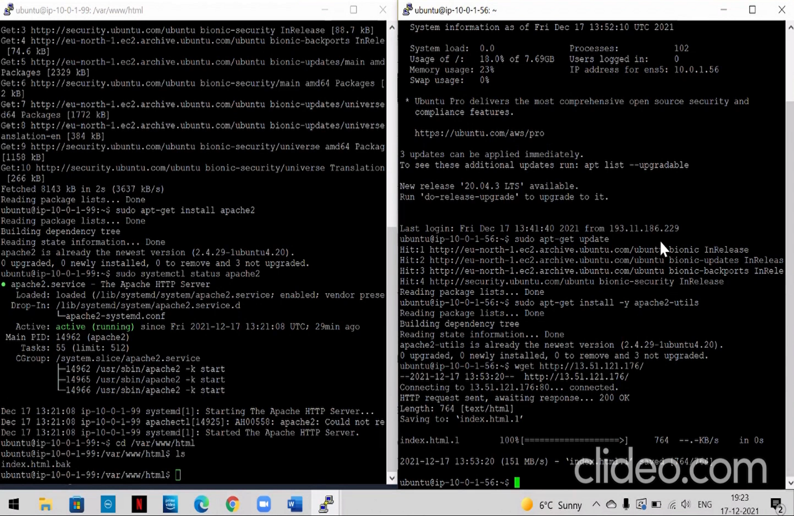

Figure 11 CONNECTION BETWEEN TWO VM’s

**1.3.4 Apache Bench stress test:**

The following command sends 100,000 http requests created by 100 and 1000 users simultaneously to a Virtual machine web server with a public IP address of “13.51.121.176”. Comparison between the stress of webpage when number of requests increased is observed. The following commands are given:

**ab -n 100000 -c 100** [**http://13.51.121.176/var/www/html**](http://13.51.121.176/var/www/html)

**ab -n 100000 -c 1000** [**http://13.51.121.176/var/www/html**](http://13.51.121.176/var/www/html)

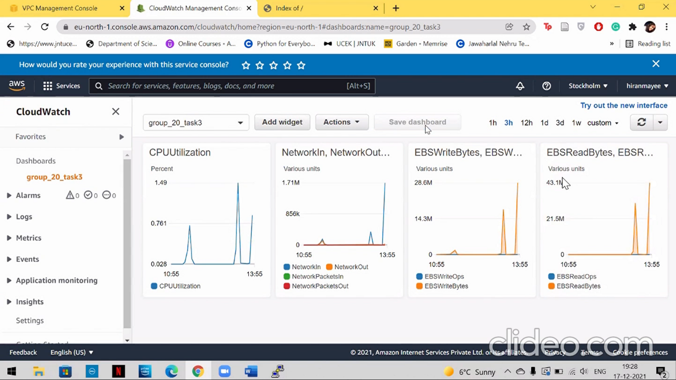

Figure 12 MONITORING METRICS

**MOTIVATION:**

Linking both the VMs was a tedious task as we didn’t have enough knowledge at the start. As we performed and failed the tasks few times, we gathered all the commands from different sources. Performing a benchmark test was a simple as it was an application.